CHARLES DARWIN UNIVERSITY
PRT661 – Data Science Practice
Assessment 1: Project Proposal and Design
Theme 2 – Predictive Analytics and Forecasting
Deep Learning-Based Detection of Defective Photovoltaic Cells from Electroluminescence Images
Group Members | [Insert names – 3 to 5 members]
Student IDs | [Insert student IDs]
Lecturer/Tutor | [Insert name]
Semester | Semester 2, 2026
Submission Date | [Insert date]
GitHub Repository | [INSERT ACTIVE GITHUB URL]
Project Management Board | [INSERT ACTIVE GITHUB PROJECTS / JIRA / TRELLO URL]

1. Project Overview and Objectives
Photovoltaic systems play an important role in renewable-energy generation, but defects within solar cells can reduce module efficiency and long-term reliability. Electroluminescence (EL) imaging is widely used to reveal structural and electrical abnormalities that may not be clearly visible under normal illumination. However, manual inspection of EL images can be time-consuming and requires specialist knowledge. This project proposes a binary image-classification system that automatically distinguishes functional photovoltaic cells from defective cells using deep learning.
The project will use the publicly available ELPV dataset and develop a lightweight convolutional neural network (CNN) for automated defect prediction. The system will be designed as a reproducible proof-of-concept decision-support tool rather than a replacement for professional photovoltaic inspection.
- acquire, organize and audit a public photovoltaic image dataset;
- preprocess EL images into a consistent modelling format;
- develop a CNN for Functional versus Defective classification;
- address class imbalance without contaminating validation or test data;
- evaluate performance using multiple binary-classification metrics; and
- visualize predictions, model behaviour, limitations and robustness.

2. Theme Justification
The project fits Theme 2: Predictive Analytics and Forecasting because historical labelled EL images will be used to train a machine-learning model that predicts the condition of previously unseen photovoltaic cells. The target is binary: Functional or Defective. The project also covers the complete data-science workflow required for the assessment through data acquisition, structured storage, image preprocessing, predictive modelling, evaluation and visualization.

3. Problem Statement
Photovoltaic-cell defects such as cracks, electrically inactive regions, interrupted interconnections and other structural abnormalities can reduce the performance and reliability of solar modules. Manual EL-image inspection can become difficult when defects are small or visually subtle.
The research question is:
Can a deep-learning image classifier accurately distinguish functional photovoltaic cells from defective cells using electroluminescence images?
The project will focus on automated classification and performance analysis. It will not estimate electrical power loss or recommend maintenance actions.

4. Data Source and Initial System Architecture
The project will use the ELPV dataset, which contains 2,624 normalized 300 × 300 8-bit grayscale images extracted from 44 photovoltaic modules. Each image is annotated with a defect probability and photovoltaic-cell type.
For the primary binary experiment, only high-confidence samples will be retained: defect probability 0.0 as Functional and 1.0 as Defective. Intermediate probability labels will be excluded from the primary classifier to reduce ambiguity in the target definition.

5. Workflow and Analytical Plan
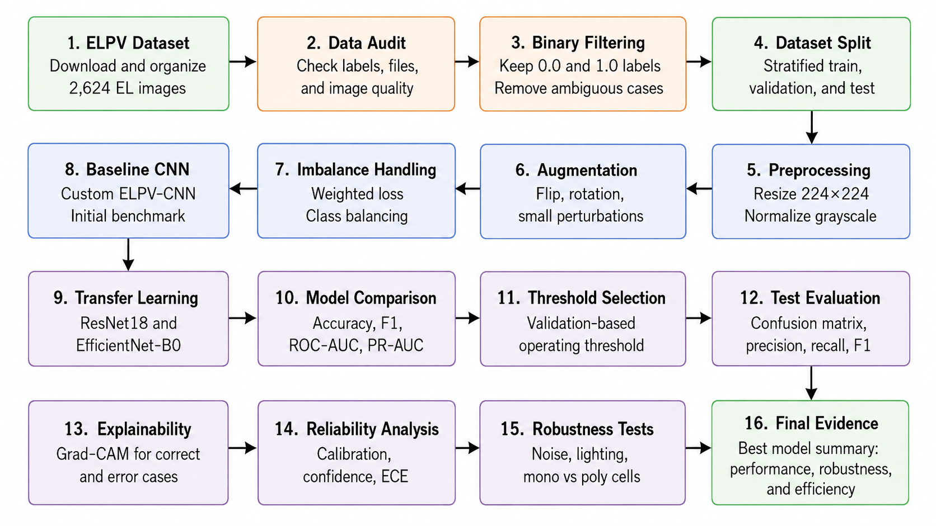
The project will use Python, PyTorch, NumPy, Pandas, Scikit-learn and Matplotlib. Dataset annotations, image dimensions, class distribution and corrupted files will first be audited. Images will then be resized to a consistent input size and normalised. Appropriate training-only augmentation may include small rotations, horizontal or vertical transformations where physically reasonable, brightness adjustment and limited noise. A stratified train-validation-test split will be created before augmentation to prevent data leakage. Because the expected Functional and Defective class counts are unequal, imbalance will be addressed only within the training process, using class weighting or a weighted sampler if required. Validation and test distributions will remain untouched. A lightweight custom CNN will serve as the primary model. Performance will be evaluated using accuracy, precision, recall, F1-score, ROC-AUC, Precision–Recall curves and a confusion matrix. Recall for defective cells will be particularly important because a false negative represents a defective solar cell incorrectly classified as functional. For the later extended report, additional analyses can include Grad-CAM interpretation, confidence and calibration analysis, PCA/t-SNE feature visualization, augmentation ablation, perturbation robustness, model-efficiency analysis and comparison with selected pretrained architectures.

Figure 1: Overall Methodological Workflow

6. Project Management and Task Allocation
A shared GitHub repository will maintain source code, notebooks, documentation, diagrams, experiment outputs and report materials. GitHub Projects or another approved project-management platform will be used to track tasks, milestones, progress and responsibilities.
Table 2. Proposed team structure and responsibilities.
Team member | Primary responsibility
Member 1 | Data acquisition and repository setup
Member 2 | Image preprocessing and exploratory analysis
Member 3 | CNN development and model training
Member 4 | Evaluation, visualization and error analysis
Member 5 | Documentation, ethics review and final integration

7. Initial Risk Analysis
Table 3. Initial project risks and mitigation strategies.
Risk | Potential impact | Mitigation
Class imbalance | Bias toward functional cells | Training-only weighting/sampling and balanced metrics
Ambiguous defect labels | Uncertain target definition | Use only high-confidence 0.0 and 1.0 labels initially
Overfitting | Poor generalization | Augmentation, dropout and early stopping
Data leakage | Inflated performance | Split before augmentation and perform duplicate auditing
Subtle defects | Higher false-negative rate | Analyze recall, errors and Grad-CAM
Domain shift | Lower performance on other EL systems | Conduct robustness testing and state dataset limitations
Version/data loss | Inconsistent team outputs | GitHub version control and regular backups

8. Ethics, Privacy and Security Considerations
The dataset contains photovoltaic-cell images rather than identifiable human information, so personal privacy risk is minimal. Nevertheless, licensing, dataset attribution and data provenance will be respected. The official dataset is released under a Creative Commons Attribution-Non-Commercial-Share Alike license for the images.
The principal ethical risk is overstating model capability. High performance on a controlled EL dataset does not guarantee equivalent performance across different photovoltaic manufacturers, imaging systems or field environments. Therefore, results will be presented as experimental evidence rather than as a certified industrial inspection system. False negatives, class imbalance, uncertain labels and generalization limitations will be reported transparently.
References
Buerhop-Lutz, C., et al. (2018). A Benchmark for Visual Identification of Defective Solar Cells in Electroluminescence Imagery. European PV Solar Energy Conference and Exhibition.
Deitsch, S., et al. (2019). Automatic classification of defective photovoltaic module cells in electroluminescence images. Solar Energy, 185, 455–468.
Deitsch, S., et al. (2021). Segmentation of photovoltaic module cells in uncalibrated electroluminescence images. Machine Vision and Applications, 32(4).
Dataset link: https://pypi.org/project/elpv-dataset/

